Form A: Request for IRB Review of Research Involving Human Subjects
Rochester Institute of Technology
Institutional Review Board
585-475-2167 ~ www.research.rit.edu/hsro ~ hsro@rit.edu
Office Use Only

Signed original received: _____________
Received by: ______________________
Electronic copies received: ___________
- To be completed by the investigator after reading the RIT Policy for the Protection of Human Subjects in Research, found in the Institute Policies and Procedures Manual, Section C5.0, and on the Office of Human Subjects Research website, http://www.rit.edu/research/hsro/process_geninfo.php.
- Submit BOTH, an electronic version to hsro@rit.edu AND the signed original of the completed Form A AND ALL attachments (consents, instruments, tasks, etc.) to HSRO, University Services Center, Suite #2400
Project Title:
Success Factors in Volunteer Prosthetic Fabrication
Investigator’s Name:  Jeremiah Parry-Hill |  | Investigator’s Phone:  585-475-2493 |  |  | Investigator’s Email:  jlpetc@rit.edu
Investigator’s College and Department:
GCCIS, Human-Computer Interaction
Project Start Date:  January 1, 2015 |  |  |  | Date of IRB Request:  November 25, 2014
If Student, Name of Faculty Supervisor:  Daniel Ashbrook |  |  | Faculty’s Phone:  585-475-4784 |  | Faculty’s Email:  Daniel.Ashbrook@rit.edu
If Not Employed or a Student at RIT, List Name, College & Dept. of RIT Collaborator: |  |  | RIT Collaborator’s Phone: |  | RIT Collaborator’s Email:
Will this project be funded externally? Yes No |  |  |  | Is the Investigator a student? Yes No
If yes, name of funding agency:
Status of project: | Submitted on |  |  | Funding pending |  | Funding confirmed
Do you have a personal financial relationship with the sponsor? Yes No
If yes, please read RIT policy C4.0 – Conflict of Interest Policy Pertaining to Externally Funded Projects. Complete the Investigator’s Financial Disclosure Form and attach it to this Form A. All information will be kept confidential.
BY MY SIGNATURE BELOW, I ATTEST TO AN UNDERSTANDING OF AND AGREE TO FOLLOW ALL APPLICABLE RIT, SPONSOR, NEW YORK STATE, AND FEDERAL POLICIES AND LAWS RELATED TO CONDUCTING RESEARCH WITH HUMAN SUBJECTS. If significant changes in investigative procedures are needed during the course of this project, I agree to seek approval from the IRB prior to their implementation. I further agree to immediately report to the IRB any adverse incidents with respect to human subjects that occur in connection with this project.
Signature of Investigator |  |  |  |  |  |  | Date
Signature of Faculty Advisor (for Student) or RIT Collaborator (for External Investigator) |  |  |  |  |  |  | Date
Signature of Department Chair or Supervisor |  |  |  |  |  |  | Date
Complete the attached Research Protocol Outline and attach to this cover form with other required attachments.
Attachments required for all projects:
Project Abstract Investigator Responsibilities and Informed Consent
Training Certificate(s) from OHRP (see http://ohrp-ed.od.nih.gov/)
Attachments required where applicable:
Informed Consent Materials Cover letter to subjects and/or parents or guardians
Questionnaire or survey External site IRB approval
Relevant Grant Application(s) Other
Letter of Support from School Principal
Form A (continued): Research Protocol Outline

- The RIT Institutional Review Board (IRB) categorizes Human Subjects Research into three Risk Types (Exempt, No Greater than Minimal Risk, and Greater than Minimal Risk, defined at the end of this form). The IRB makes the final determination of risk type.
- Please complete this entire form (1 through 10 below). ENTER A RESPONSE FOR EVERY QUESTION. If a question does not apply to your project, please enter “N/A”. Leaving questions blank may result in the form being returned to you for completion before it is reviewed by the IRB.
- Underlined terms are defined at the end of this form.

FOR ALL PROJECTS, please complete 1-10 below.
If you believe your project qualifies for Exemption, which exemption number(s) apply?
(Note: The IRB makes the final determination of Exemption)
We believe this project qualifies for exemption under #2 (45 CFR 46.101(b)(2)).

- Describe the research problem(s) your project addresses.
Previous research has argued that certain barriers to participation might prevent volunteers from using home fabrication technology to produce assistive technology. These barriers include access to technology, perceived expertise, and available time to fabricate. The goal of this study is to capture and summarize the success factors in a community of volunteer fabricators, the e-NABLE Google+ community.

- Describe expected benefits to subjects and/or knowledge to be gained from your project.
We as researchers will gain an increased understanding of the challenges encountered by the participants in this community, and will convey that information back to the community. In addition, some of the workarounds to common barriers may be applicable to the subjects’ own experience.
- Describe the population sample for your project.
  - How many subjects will participate in this project?
A minimum of five subjects will be included in this study.
  - How will these subjects be identified and selected for participation?
Subjects will be identified by their involvement in the e-NABLE Google+ community.
Subjects will be selected based on their current use of home fabrication technologies to create assistive technologies.
  - Describe the rationale for inclusion or exclusion of any subpopulation.
Subjects that are not home fabricators, or are not fabricating assistive technology, will not be selected for interviews. The scope of this study is limited to home fabricators of assistive technology.
We will not include subjects who are under the age of 18.
We will not include subjects who are not located in the US (see 4a below).
  - How will you recruit subjects?
Subjects will be recruited via advertisement through the e-NABLE Google+ group.
We will direct them to an online survey. A portion of survey respondents will be invited to participate in interviews via email.
  - Describe any incentives for participation you plan to use.
No material incentives will be offered for participation in this study.
- Will you include any of the following vulnerable populations in your research? (Check any that apply)
Children Mentally Ill
Prisoners Mentally Handicapped/Retarded
Pregnant Women Fetuses
If any of these populations are to be included, please addresses the following:
  - Rationale for selecting or excluding a specific population:
This study will not consciously exclude or include any of the groups listed above. Because participation requires access to home fabrication technology, the population is likely to be adults. This implies an indirect exclusion of children and prisoners. We will not request disclosure of the health status of subjects. Because fabrication of prosthetics is not legal in all regions and countries, we are including only US residents in this study.
  - Description of the expertise of project personnel for dealing with vulnerable populations:
N/A
  - Description of the suitability of the facilities for the special needs of subjects:
All interviews with non-local subjects will be conducted through web conferencing (Google Hangouts or Skype). If non-local subjects are Deaf/hard-of-hearing, interviews will be conducted via text chat.
Interviews with local subjects will be conducted in a private facility on the RIT campus.
  - Inclusion of sufficient numbers of subjects to generate meaningful data:
Our data will not rely on any health/personal details, and so will not require a target distribution of subjects from these populations.
- Describe the data collection process.
  - Will the data collected from human subjects be anonymous? Yes No
  - Will the data collected from human subjects be kept confidential? Yes No
  - Describe your procedures for ensuring anonymity and/or confidentiality:
      - All electronic interview recordings, transcripts, and notes will be kept in RIT-hosted repository accessible only to the researchers (via a private password and encryption key).
      - All paper materials will be filed in a locked cabinet accessible only to the researchers.
      - Any email or online communications (e.g. interview scheduling, etc.) will be via the investigators’ password-protected RIT email accounts. Participants will be informed of the level of security on these accounts and advised not to include overly personal or sensitive information in online communications.

  - How much time is required of each subject? Initial interviews will have a target duration of one hour. Follow-up interviews, if needed, will take a similar amount of time.

  - If subjects are students, will their participation involve class time? No
  - What methods, instruments, techniques, and/or other sources of material will you use to gather data from human subjects?
An online questionnaire that asks respondents to characterize their experiences with home fabrication.

Semi-structured interviews consisting of open-ended questions regarding:
      - How home fabrication technology is used by the subject
      - The subject’s role in the online community of volunteers
      - Any technical difficulties or workarounds encountered by the subject in the process of fabrication
      - Current fabrication concerns and perceived opportunities for future improvement

- Will this research be conducted at another university or site other than RIT? Yes No
If yes, describe location: Interviews with the majority of subjects will be completed over video conference.
Note: If you will be conducting human subjects research at another university or college, you will also need to obtain IRB approval from that institution. Attach a copy of that approval to this application.
- Describe potential risks (beyond minimal risk) to subjects:
  - Are the risks physical, psychological, social, legal or other?
The risks to subjects are no greater than the risks encountered in the normal use of a computer.
  - Assess their likelihood and seriousness to subjects: n/a
  - Discuss the potential benefits of the research to the population from which your subjects are drawn:
The general patterns identified by this project will contribute to the body of knowledge around home fabrication technologies as they are used by nonprofessionals.
We as researchers will gain an increased understanding of the challenges encountered by the participants in this community, and will convey that information back to the community. In addition, some of the workarounds to common barriers may be applicable to the subjects’ own experience.

  - Discuss why the risks to subjects are reasonable in relation to the anticipated benefits to subjects and others, or in relation to the importance of the knowledge to be gained as a result of the proposed research:
The risk to subjects has a very low likelihood, accompanied by a reasonable expectation of short-term benefit to all subjects. The knowledge gained has the potential to benefit the human-computer interaction community at large, by describing a model of successful small-scale fabrication.
  - Describe the planned procedures for protecting against or minimizing potential risks, including risks to confidentiality, and assess their likely effectiveness:
During interviews, if the researchers judge that the information being disclosed will pose a potential risk to the subject, the interview will be stopped at that point and the issue addressed before resuming.
  - Where appropriate, describe plans for ensuring necessary medical or professional intervention in the event of adverse effects to the subjects:
Not applicable.
- Will you be seeking informed consent? Yes No
If yes, describe:
  - What information will be provided to prospective subjects?
Project summary, subject expectations, potential benefits and risks.
  - What (if any) information will be concealed prior to participation, and why?
None
  - How will you ensure consent is obtained without real or implied coercion?
The consent form will be provided to anyone interested in participating in the study, regardless of any commitment to participate. Consent will be obtained prior to scheduling any interviews, in order to prevent time pressure or expectation of participation to bias the subjects.
  - How will you obtain and document consent?
Consent will be obtained through the online survey. A copy of the consent form will be stored with the subject’s research record.
  - Who will be obtaining consent? Provide names of specific individuals, where available, and detail the nature of their preparation and instructions for obtaining consent.
Jeremiah Parry-Hill
Daniel Ashbrook
Tiago Justino

- Attach a copy of all additional materials (Consents, protocol, scripts, instruments, tasks, etc.- everything a subject does or sees) to this application.

- Appendix A: Informed Consent Agreement
- Appendix B: Project Abstract
- Appendix C: IRB Training Certifications
- Appendix D: Recruitment Materials
- Appendix E: Online Survey and Interview Guide

RIT IRB Risk Type Classification

Exempt
Research activities in which the only involvement of human subjects will be in one or more of the following six categories of exemptions are not covered by the regulations:
- Research conducted in established or commonly accepted educational settings, involving normal educational practices, such as (a) research on regular and special education instructional strategies, or (b) research on the effectiveness of or the comparison among instructional techniques, curricula, or classroom management methods.
- Research involving the use of educational tests (cognitive, diagnostic, aptitude, achievement), survey procedures, interview procedures or observation of public behavior, unless: (a) information obtained is recorded in such a manner that human subjects can be identified, directly or through identifiers linked to the subjects; and (b) any disclosure of the human subjects’ responses outside the research could reasonably place the subjects at risk of criminal or civil liability or be damaging to the subjects’ financial standing, employability, or reputation. If the subjects are children, this exemption applies only to research involving educational tests or observations of public behavior when the investigator(s) do not participate in the activities being observed. [Children are defined as persons who have not attained the legal age for consent to treatments or procedures involved in the research, under the applicable law or jurisdiction in which the research will be conducted.]
- Research involving the use of educational tests (cognitive, diagnostic, aptitude, achievement), survey procedures, interview procedures or observation of public behavior that is not exempt under section (2) above, if the human subjects are elected or appointed public officials or candidates for public office; or federal statute(s) require(s) without exception that the confidentiality of the personally identifiable information will be maintained throughout the research and thereafter.
- Research involving the collection or study of existing data, documents, records, pathological specimens, or diagnostic specimens, if these sources are publicly available or if the information is recorded by the investigator in a manner that subjects cannot be identified, directly or through identifiers linked to the subjects.
- Research and demonstration projects which are conducted by or subject to the approval of department or agency heads, and which are designed to study, evaluate, or otherwise examine: (a) public benefit or service programs; (b) procedures for obtaining benefits or services under those programs; (c) possible changes in or alternatives to those programs or procedures; or (d) possible changes in methods or levels of payment for benefits or services under those programs.
- Taste and food quality evaluation and consumer acceptance studies, (a) if wholesome foods without additives are consumed or (b) if a food is consumed that contains a food ingredient at or below the level and for a use found to be safe, or agricultural chemical or environmental contaminant at or below the level found to be safe, by the Food and Drug Administration or approved by the Environmental Protection Agency or the Food Safety and Inspection Service of the US Department of Agriculture.

No Greater than Minimal Risk – The probability and magnitude of harm or discomfort anticipated in the research is no greater than those ordinarily encountered in daily life or in the performance of routine physical and psychological examinations or tests.

Greater than Minimal Risk – The probability and magnitude of harm or discomfort anticipated in the research is greater than those ordinarily encountered in daily life or in the performance of routine physical and psychological examinations or tests.
Human Subjects Research - Definitions
Anonymity – Anonymity offers the best insurance that disclosure of subjects’ responses will not occur. Research data that is anonymous contains no information that would link the data to the individual who provided the information.
Confidentiality – Confidentiality refers to (a) identifiable data (some information about a person that would permit others to identify the specific person, such as a non-anonymous survey, notes or a videotape of the person) and (b) agreements about how those data are to be handled in keeping with respondents’ interest in controlling the access of others to information about themselves. The two critical elements of this definition of confidentiality indicate the critical role of informed consent, which states how the researcher will control access to the data and secures the respondent’s agreement to participate under these conditions.
Child (Definition of) and Use of Children in Research - Children are defined as persons who have not attained the legal age for consent to treatments or procedures involved in the research, under the applicable law or jurisdiction in which the research will be conducted. In New York State, a person age 18 is considered an adult and can provide consent without parental permission. However, some students at RIT are under age 18. To use children (individuals under the age of 18 years) in research, you must first obtain the permission of the parent(s) and then obtain assent from the child.
Human Subjects - The regulations define human subject as “a living individual about whom an investigator (whether professional or student) conducting research obtains (1) data through intervention or interaction with the individual, or (2) identifiable private information.” (1) If an activity involves obtaining information about a living person by manipulating that person or that person’s environment, as might occur when a new instructional technique is tested, or by communicating or interacting with the individual, as occurs with surveys and interviews, the definition of human subject is met. (2) If an activity involves obtaining private information about a living person in such a way that the information can be linked to that individual (the identity of the subject is or may be readily determined by the investigator or associated with the information), the definition of human subject is met. [Private information includes information about behavior that occurs in a context in which an individual can reasonably expect that no observation or recording is taking place, and information which has been provided for specific purposes by an individual and which the individual can reasonably expect will not be made public (for example, a school health record).]
Informed Consent – Informed consent is a process by which individuals learn about a study – the substantive issue investigated, participation demands (including time expenditure, types of activities), participant rights (voluntariness, confidentiality), risks, benefits, costs/compensation, contacts if further questions arise, etc. There are multiple ways to convey these elements of consent: by written document, oral presentation with script, oral presentation without script. In addition, there are various ways to document consent: written signature of the participant, written indication of participant’s study identification number, oral recording of consent, oral consent documented by the investigator. In addition, sometimes it is important to obtain separate consent for the use of photographs or videotaped images. The different ways to obtain consent include:
- Written consent with written documentation by participant.
- formal style (for study involving mothers and children)
- informal style
- formal style for at-risk population
- Written consent with written indication of participant’s study identification number.
- Written consent without documentation (for no/minimal risk survey studies).
- Oral presentation with script with oral consent documented by the investigator.
- Oral presentation with script without documentation (includes contact card).
- Oral presentation without script without documentation (provides rationale for request for waiver of written documentation and indicates what will be said).
- Written consent with written documentation by participant for use of photos.

Population Sample
- Describe the proposed involvement of human subjects in your project.
- Describe the characteristics of the subject population, including their anticipated number, age range, and health status.
- Identify the criteria for inclusion or exclusion of any subpopulation.
- Explain the rationale for the involvement of special classes of subjects.
Research Activity - The ED Regulations for the Projection of Human Subjects, Title 34, Code of Federal Regulations, Part 97, define research as “a systematic investigation, including research, development, testing and evaluation, designed to develop or contribute to generalizable knowledge.” If an activity follows a deliberate plan whose purpose is to develop or contribute to generalizable knowledge, such as an exploratory study of the collection of data to test a hypothesis, it is research. Activities which meet this definition constitute research whether or not they are conducted or supported under a program which is considered research for other purposes. For example, some demonstration and service programs may include research activities.
Risks in Research – As with any activity, there is potential for harm in the social and behavioral sciences – from inconvenience or embarrassment to stigma or legal or economic consequences. Typically, however, in these sciences both the potential harms and the risks of them are minimal and not of the type routinely being assessed in biomedical research. Much of the risk relates to disclosure of the identity of human subjects or the information they provide; thus, considerable effort in these sciences is devoted to safeguarding subjects’ privacy and the confidentiality of the data they provide even when the information has no or minimal potential for harm.
Minimal risk means that the probability and magnitude of harm or discomfort anticipated in the research are not greater in and of themselves than those ordinarily encountered in daily life or during the performance of routine physical or psychological examinations or tests. “Risk” refers to a probability that some harm will occur. “Harm” refers to a specific outcome(s) or event(s) – and can be inconvenience, physical, psychological, social, economic, or legal in nature. If human subjects are exposed to a degree of harm roughly equivalent to what one would expect in the course of daily life or in the course of routine tests and examinations, then “minimal risk” applies.

Sources of Materials
- Identify the sources of research material to be obtained from individually identifiable living human subjects in the form of specimens, records, or data.
- Indicate whether the material or data will be obtained specifically for research purposes or whether use will be made of existing specimens, records, or data.

Appendix A:
Informed Consent Agreement:
Success Factors in Volunteer Prosthetic Fabrication
You are invited to join a research study to identify the factors that lead to successful small-scale fabrication of prosthetics being conducted by Jeremiah Parry-Hill and Tiago Justino, under supervision of Dr. Daniel Ashbrook, at the Rochester Institute of Technology. Please take whatever time you need to discuss the study with your family and friends, or anyone else you wish to. The decision to join, or not to join, is up to you. At this time, we are recruiting active makers who are US residents aged 18 or older.
WHAT IS INVOLVED IN THE STUDY?
You will be asked to participate in a one-hour, semi-structured interview regarding your motivations for fabricating prosthetics, and your work practices around fabrication. We will record these interviews. You may also be asked to participate in follow-up interviews/meetings to clarify any open questions and to review the investigators’ final notes and project summary. You can stop participating at any time.
The investigators may stop the study, or take you out of the study, at any time they judge it is in your best interest. They may also remove you from the study for various other reasons. They can do this without your consent. The most likely reason for removal from the study is determination that your prosthetic fabrication practices are out of scope for this study. If you stop or are removed, you will not lose any benefits.
INTENDED BENEFITS
It is reasonable to expect the following benefits from this research:
- Insight into your own prosthetic manufacturing practices and motivations
- We will gain an increased understanding of the challenges encountered by the community members, and will convey that information back to the community. In addition, some of the workarounds to common barriers may be applicable to your own experience.
However, we can’t guarantee that you will personally experience benefits from participating in this study. Others may benefit in the future from the information we find in this study.
RISKS AND CONFIDENTIALITY
The investigators will take precautions to protect any personal or sensitive information. However, as this study is interested only in manufacturing practices, you are advised not to disclose information protected by other constraints (e.g. employer proprietary information, applicable laws, etc.).
Your name will not be used when data from this study are published. Every effort will be made to keep your personal information confidential. We will take the following steps to keep information about you confidential, and to protect it from unauthorized disclosure, tampering, or damage:
- All electronic interview recordings, transcripts, and notes will be kept in RIT-hosted repository accessible only to the researchers (via a private password and encryption key).
- All paper materials will be filed in a locked drawer in a locked office accessible only to the researchers.
- Any email or online communications (e.g. interview scheduling, etc.) will be via the investigators’ password-protected RIT email accounts. We will never include overly personal or sensitive information in online communications.
- Any quotes used from interviews will be de-identified by the use of an anonymous identifier.

YOUR RIGHTS AS A RESEARCH PARTICIPANT
Participation in this study is voluntary. You have the right not to participate at all or to leave the study at any time. Deciding not to participate or choosing to leave the study will not result in any penalty or loss of benefits to which you are entitled, and it will not harm your relationship with the research team or RIT. If you decide to leave the study, notify the research team. From that point forward, all pending appointments will be cancelled and you will be removed from future communications regarding the study.
Contact Jeremiah Parry-Hill (at 585-475-2493 or jlpetc@rit.edu), Tiago Justino (585-369-4363 or tiago.justino@mail.rit.edu) or Dr. Daniel Ashbrook (at 585-475-4784 or Daniel.ashbrook@rit.edu) if you have questions about the study, any problems, unexpected physical or psychological discomforts, any injuries, or think that something unusual or unexpected is happening.
Heather M. Foti, Associate Director of RIT’s Human Subjects Research Office (HSRO), is also available (at 585-475-7673 or hmfsrs@rit.edu) if you have questions or concerns about your experience as a research subject.
Appendix B:
Project Abstract: Success Factors in Volunteer Prosthetic Fabrication

The falling cost of fabrication technology, such as 3D printing, has made it possible for amateurs to make objects that are comparable to commercial products. Prosthetic assistive technology is particularly appealing to amateurs, as it is customized to each user, expensive to acquire, and when the user is a child, requires replacement throughout childhood development.

Previous research has argued that certain barriers to participation might prevent volunteers from using home fabrication technology to produce assistive technology.

We will study one community of volunteers that has organized around 3D printing prosthetic hands. This project will study the factors that motivate and enable volunteer fabricators to manufacture assistive technology, as well as their experiences with technology.

Appendix C: IRB Training Certifications o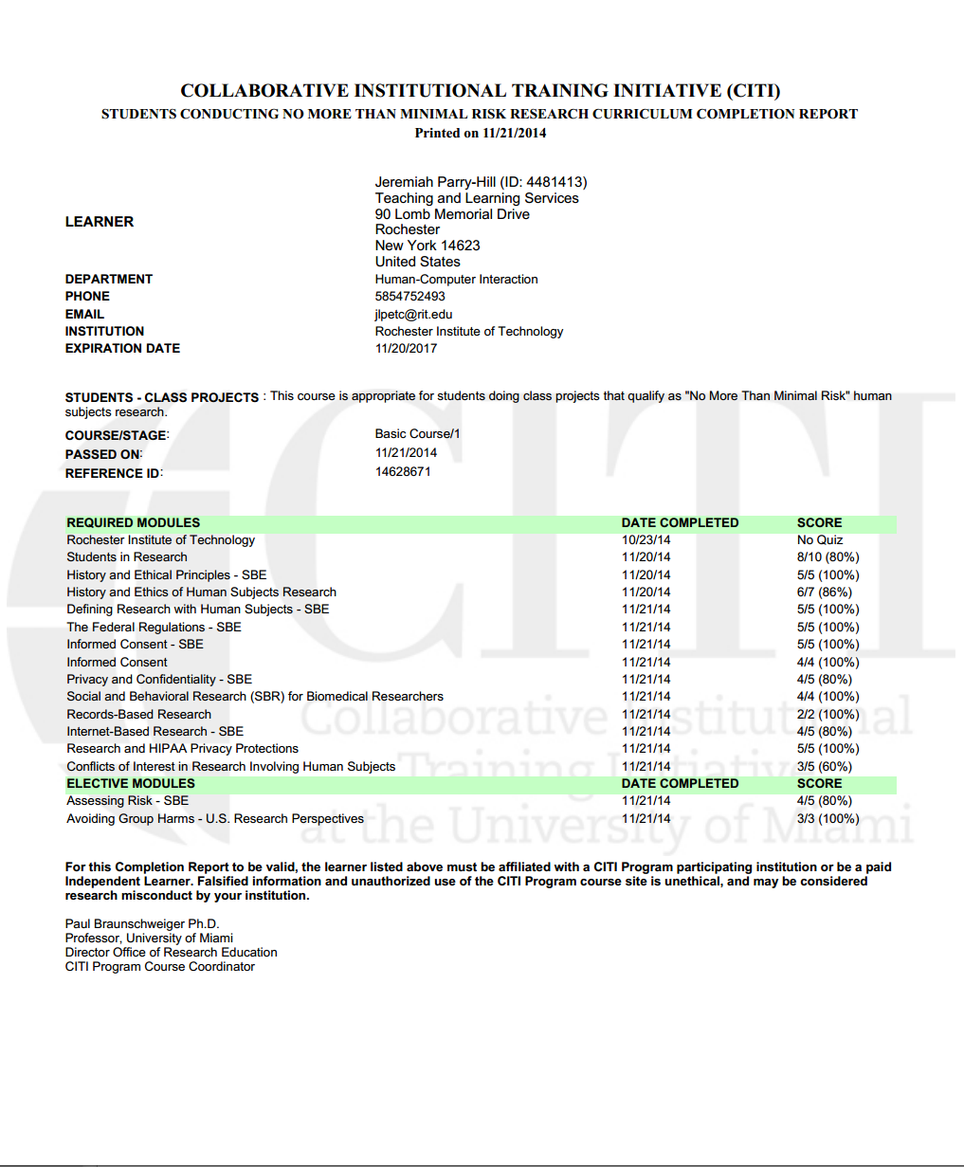

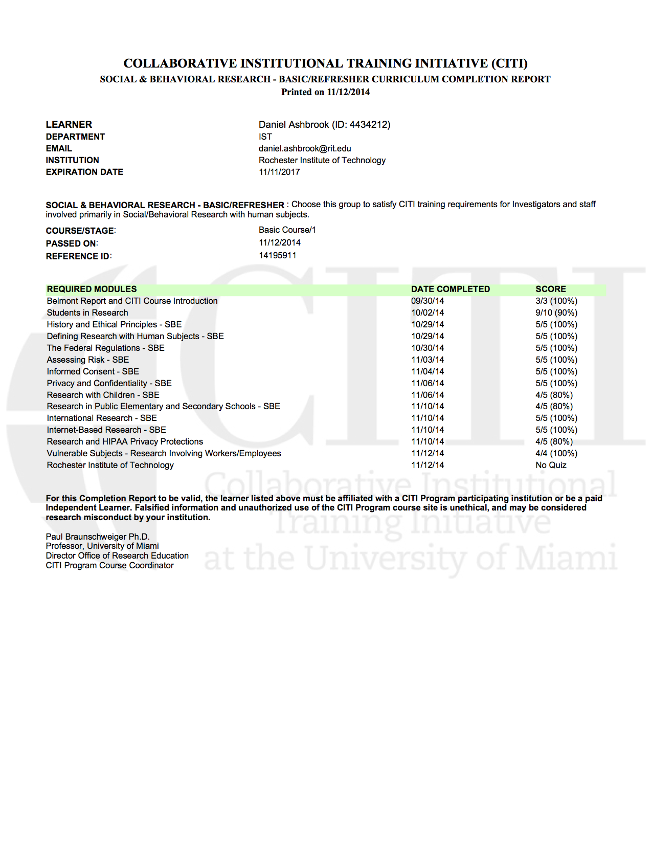
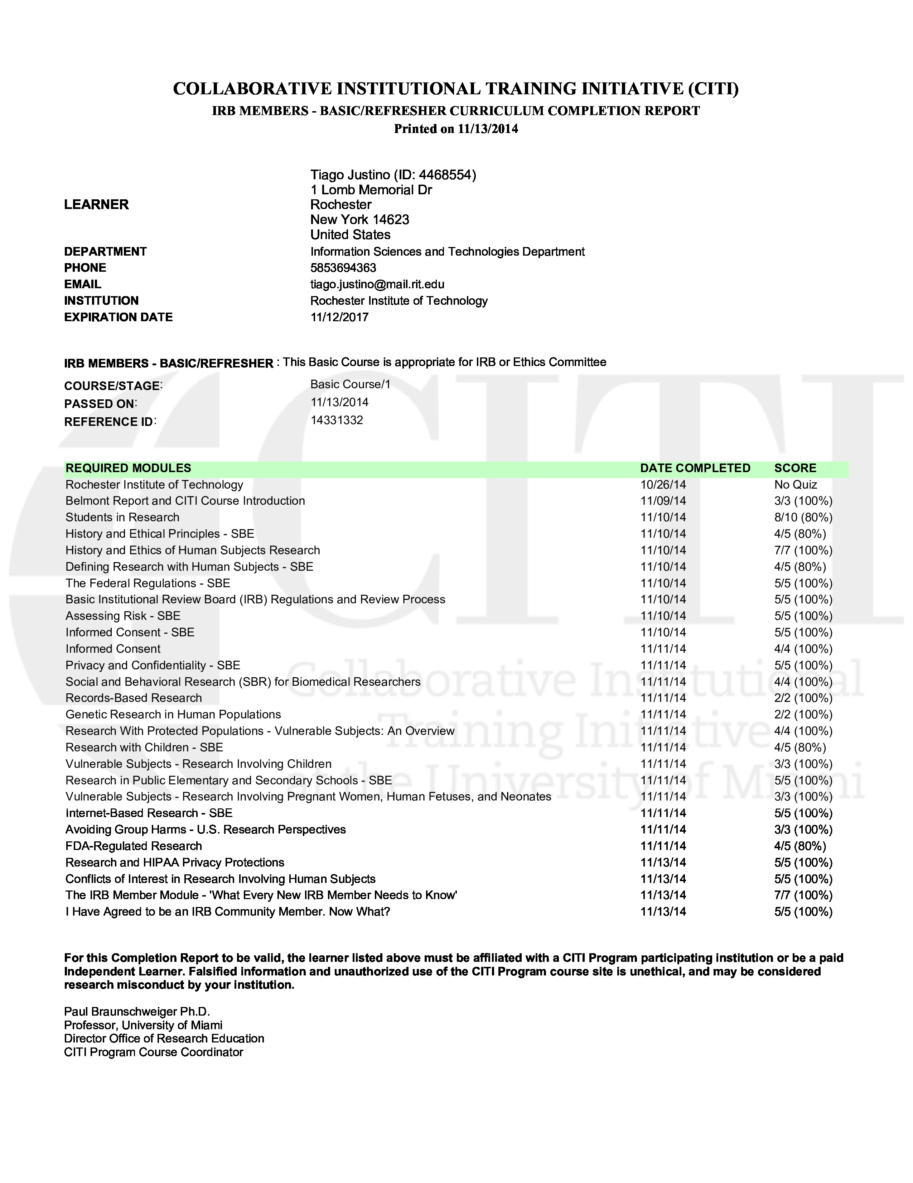

Appendix D: Recruitment Materials

Recruitment advertisement to be posted to e-NABLE Google+ group:

Researchers from Rochester Institute of Technology are studying success factors in online communities of volunteer makers. Active makers who are US residents aged 18 or older are invited to apply to participate in this study.

Participation involves an online survey, with a potential for a one-hour interview over Google Hangouts or Skype, and the potential for follow-up interviews.

Interested participants are invited to complete the survey at: (survey link)

Email invitation to selected participants:

Based on your responses to our online survey, you are invited to participate in an online interview about your experiences as part of the e-NABLE community.

If you are interested, please respond with your preferred contact information (Skype or Google Hangouts, and username), and select one of the interview times below in US Eastern time:

(list of potential interview times follows)

If you are in the Rochester, NY area, please let us know if you would prefer to conduct the interview in-person on the RIT campus.

Confidentiality note: We are conducting this invitation over an RIT email account, which is secured by an RIT account password. We will make every effort to protect the information you share during interviews, but we would remind you not to share personal/confidential information over email.
Appendix E: Online Survey and Interview Guide

Online questionnaire for participants:

(On the first screen, the respondent will see the project abstract and informed consent.)
(Invite respondent to print/save informed consent.)
(note: include a “prefer not to say” option for all responses)

Age: _____
Occupation: _____
Email address: _____
Country of residence: ______ (note: if not US, stop here)

When did you join the e-NABLE community?

How have you benefited from being a part of the e-NABLE online community?

Do you primarily identify as:
- A maker
- A designer
- A community member
- Other: _____

Maker/Designer Section:
Please describe your experience and background with making in general:

In a given week, how many hours do you spend making things? _____

Please indicate any of the technologies that you have access to:
- 3D Printer
- Laser cutter
- CNC router
- Other: _____

Which software do you use for making or designing?

How do you get access to technologies for making? (select all that apply):
- I have them at home
- I use a friend’s
- I go to a maker/hacker space
- I use them in a public library
- Other: __________

(Branching yes/no): Have you printed a prosthetic hand for e-NABLE?

(If answered Yes to “printed a hand”):
What were your reasons for printing a hand for e-NABLE? (check all that apply):
  - To help the project generally
  - To help someone I know
  - To help myself
  - To express myself creatively
  - To use or improve my technical skills
  - To work on a project with practical benefit

If you printed a hand for a recipient, what was your relationship to that person?
- Myself
- A relative
- A friend
- Someone who I did not know personally
- Other: _____

What kind of obstacles or problems have you run into when making hands?

(If answered No to “printed a hand”):

What has prevented you from doing so?

Do you plan to do so in future?

Semi-Directed Interview Questions:

Using the survey responses as a starting point, go into further detail on:
- Experiences fabricating or designing
- Difficulties encountered
- Workarounds
- Suggestions for improvements (in processes, materials, etc.)

- Tell me more about your motivations for making (if survey response was unclear).

- How often do you find you have to reprint/refabricate a part?

- How have you benefited from being a part of the e-NABLE online community?
  - Follow-up: How would you characterize your role in the community?

Debrief (end of interview):
- Reiterate what we expect to learn from the study
- Answer any questions the participant has about the study

